Query 6

Query:

SELECT CalMonth, NULL, SUM(ExtCost) AS CostSum, SUM(Quantity) AS QuanSum FROM Inventory_fact,date_dim,cust_vendor_dim WHERE Inventory_fact.DateKey = date_dim.DateKey

AND Inventory_fact.CustVendorKey = cust_vendor_dim.CustVendorKey AND Inventory_fact.TransTypeKey = 5 AND date_dim.CalYear = 2011

GROUP BY CalMonth
UNION

SELECT CalMonth, AddrCatCode1,SUM(ExtCost) AS CostSum, SUM(Quantity) AS QuanSum FROM Inventory_fact,date_dim,cust_vendor_dim WHERE Inventory_fact.DateKey = date_dim.DateKey

AND Inventory_fact.CustVendorKey = cust_vendor_dim.CustVendorKey AND Inventory_fact.TransTypeKey = 5 AND date_dim.CalYear = 2011
GROUP BY CalMonth, AddrCatCode1
UNION

SELECT NULL,AddrCatCode1, SUM(ExtCost) AS CostSum, SUM(Quantity) AS QuanSum FROM Inventory_fact,date_dim,cust_vendor_dim WHERE Inventory_fact.DateKey = date_dim.DateKey

AND Inventory_fact.CustVendorKey = cust_vendor_dim.CustVendorKey AND Inventory_fact.TransTypeKey = 5 AND date_dim.CalYear = 2011

GROUP BY AddrCatCode1
UNION

SELECT NULL, NULL, SUM(ExtCost) AS CostSum, SUM(Quantity) AS QuanSum FROM Inventory_fact,date_dim,cust_vendor_dim WHERE Inventory_fact.DateKey = date_dim.DateKey

AND Inventory_fact.CustVendorKey = cust_vendor_dim.CustVendorKey AND Inventory_fact.TransTypeKey = 5 AND date_dim.CalYear = 2011

ORDER BY 1, 2;

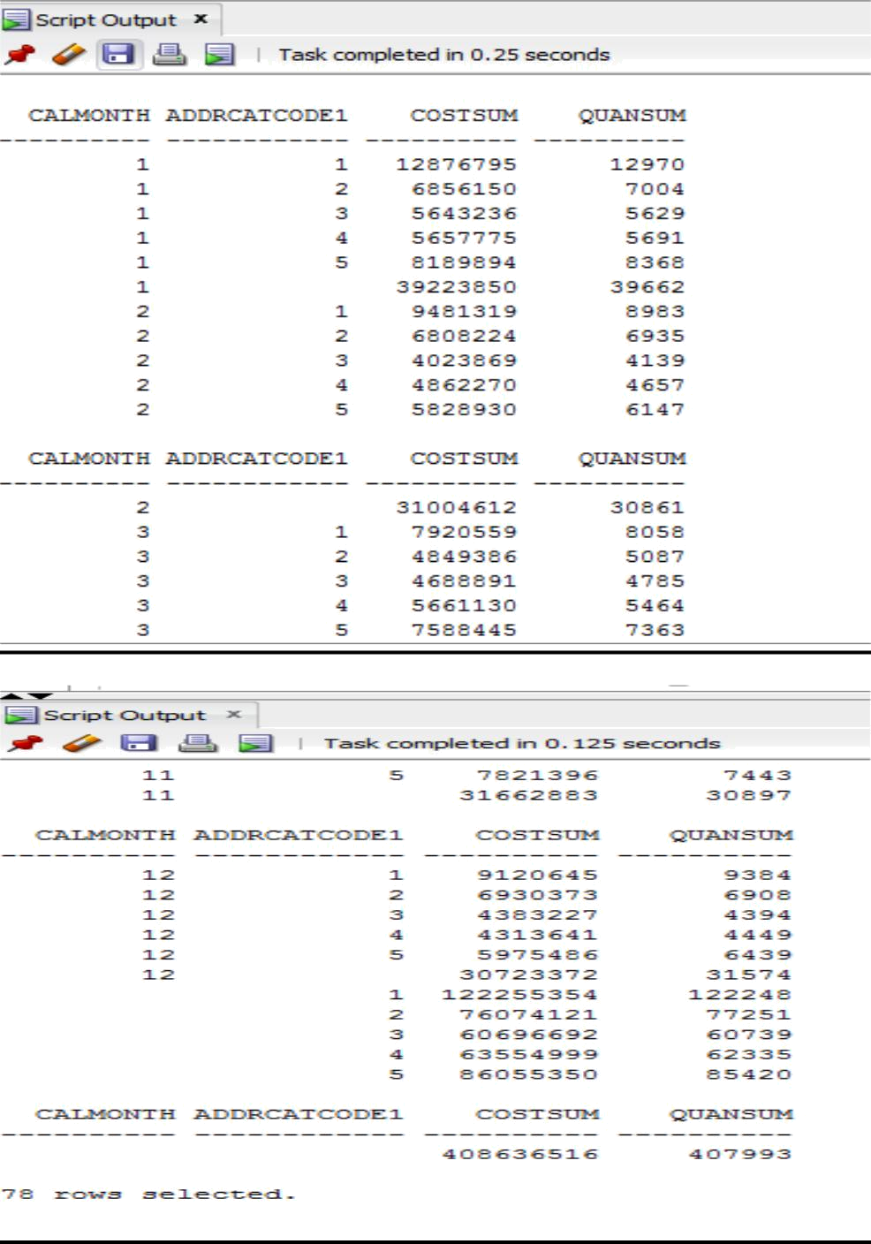
Result:78 rows

